**MIS 6308**

**Fall 2017**

**Assignment 3**

**Question 1 (10 points)**

The current Doordash system does not allow a customer to place menu items from multiple restaurants in the same order. Clearly, such a feature can be very useful to customers. On the other hand, Doordash does not want to allow the user to provide complete freedom in choosing restaurants. For example, it may not be too difficult to assemble items from restaurants that are near to each other or those that are on the way to the delivery address.

Assume we want to design a new process that will help with ordering items from multiple restaurants in the same order. However, the process should only allow the user to choose from restaurants that are “convenient” from DoorDash’s perspective. We would like to model this process as the use case ‘Order from Multiple Restaurants’ in our model.

1. Develop a use case description for it. Identify the actor and trigger. Underline data used within this use case.
2. Document the data used in this use case using the data dictionary notation.

There are multiple approaches to design this process, ranging from simple to complex. As long as you have correctly identified the process steps, trigger, actor, and the required data for your approach, you will get full credit. However, try to think of a sophisticated approach that involves using the information that Doordash already has. The key is to define what “convenient” means for Doordash and use that definition in the process.

**Question 2 (10 points)**

Consider the following class diagram.

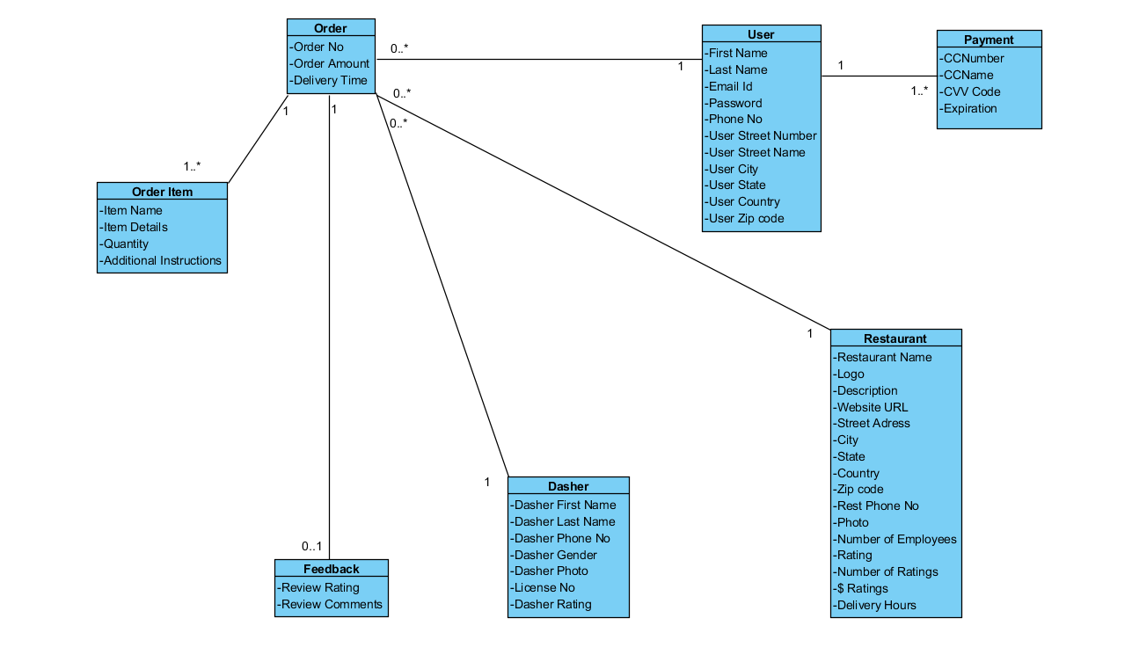

1. Identify the data elements that Doordash will store in a database as persistent data.
2. For the persistent data you identified in step 1, design a database in III Normal Form.
3. Specify the primary key, foreign key(s), and constraints for each table in your design.